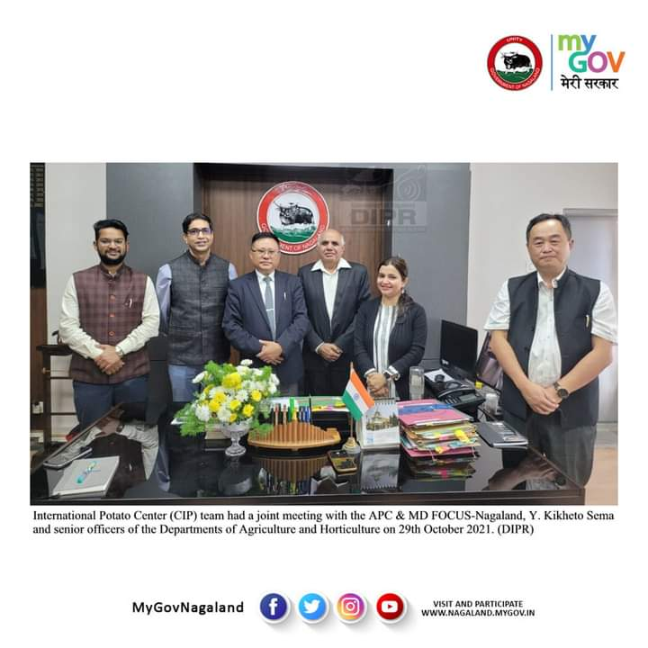
OFFICIALS OF INTERNATIONAL POTATO CENTER VISITS NAGALAND

After 19 days of the discussion held by the State officials led by APC and Mission Director, FOCUS-Nagaland, Y. Kikheto Sema, IAS with the International Potato Center (CIP) at Pusa, New Delhi on the 9th October 2021 regarding the proposal for Low-Cost Potato Seed Production System for Improved Livelihoods for Farmers of Nagaland, the Asia Regional Director of CIP Dr. Samarendu Mohanty based in Manila, Philippines, Dr. Sampriti Baruah, Project Coordinator for India, Philippines and Vietnam and Dr. Mohinder Singh, Senior Consultant have arrived in Nagaland on 28th October 2021. On arrival they visited the tissue culture laboratories and infrastructure facilities of Agriculture and Horticulture Department at Agri Expo Dimapur.
On 29th October 2021, the CIP team had a joint meeting with the APC & MD FOCUS-Nagaland and senior officers of the Departments of Agriculture and Horticulture. Kikheto Sema revealed that there is a huge demand for potato seeds in the state both during kharif and rabi seasons. He further stated that most farmers of the state cannot afford quality potato seeds from the mainland India and thus buy the unsold potatoes from the grocery shops which give poor yield. Kikheto conveyed that both the Chief Minister, Neiphiu Rio and Minister for Agriculture, G. Kaito Aye are eager to create better avenues for the farming community and more importantly bring new and innovative farming technologies to attract the educated youths towards agriculture. This, he said that, has prompted FOCUS-Nagaland to propose to IFAD (International Fund for Agriculture Development of the United Nations) to fund the project for potato seed production which will not only increase the farmers’ income but also generate employment among the educated youths of the State. He further informed that IFAD is willing to sponsor the project and once approved, the existing tissue culture laboratory at State Horticulture Nursery under the Dept. of Horticulture will be upgraded which will accommodate the requirements of the warmer foothill areas. The main tissue culture laboratory is proposed to be installed within the existing infrastructure at the State Agricultural Research Station (SARS), Yisemyong under Mokokchung district for meeting the requirements for the rest of the State with temperate and cold climate of mid and hilly areas.
Dr. Mohanty appreciated the initiatives taken by the State Government and enlightened that through the project, CIP will introduce its novel low cost technology (Apical Rooted Cutting) with the objective to develop the potato seed value chain in the state to improve productivity and to supply high quality potato seeds to our farmers at an affordable price which can also be exported to the neighboring states. It will also work towards the introduction of new short duration, early bulking, climate resilient and disease resistant potato varieties responding to consumer and market demands for table and processing purposes. He further mentioned that Nagaland has a favourable agro-climatic condition to have at least two growing seasons per year which presents an untapped opportunity to transform Nagaland into a seed production hub for the supply of quality potato seed to other States.
Later in the afternoon the CIP team proceeded for SARS, Yisemyong.

